MASTER CREATIVE SERVICES AGREEMENT BETWEEN AMBER FUND (“Client”)
AND
HALUCINATED DESIGN, INC. (“Agency”)

This Master Creative Services Agreement (“Agreement”) is entered into as of the date last signed below (“Effective Date”) by and between HALUCINATED DESIGN, INC., a New York Corporation with an address at 630 9th Ave, Suite 1411, New York, NY 10036 (“Agency”) and PAGNY | HRF, a New York organization with an address at 55 W 125th St, Suite 1001 New York, NY 10027 (“Client”).

Quote

The terms of this Quote are effective for 60 days after presentation to Client. Upon acceptance, this will constitute an Agreement between Halucinated Design and Client. In the event this Agreement is not executed by Client within the time identified, the Quote, together with any related terms and conditions and/or deliverables, may be subject to amendment, change, or substitution.

Expenses

Out of pocket expenses, such as travel, accommodations stock media purchase, equipment rental, template media purchases, voiceover, and stock photography, are not included and would be quoted separately. Applicable New York sales tax (if necessary) is not included in a cost estimate.

Timing

All suggested milestone dates and timeframes should be recognized as targets and are subject to change based on schedule availability of participants and timely review and approval of deliverables. For the project to officially commence, the final project quote must be signed.

Invoices

Invoices are payable upon receipt. Author’s Alterations (see below) will be invoiced separately.

Author’s Alterations

Client shall pay additional charges for changes or additional steps requested by Client which are not described by the scope in the official Quote. Charges will be in addition to all other amounts payable under the Quote, despite any maximum budget, contract price, or final price identified therein. Halucinated Design will quote author’s alterations before beginning work. Author’s alterations requested by the client may extend or modify the final delivery schedule.

Client Responsibilities

Client is responsible for performing the following: (a) coordination of any decision-making with parties other than Halucinated Design (b) submittal of Client content in a form suitable for reproduction or incorporation into deliverables (c) final proofreading and, in the event that Client has approved deliverables, but errors such as by way of example, but not limitation, typographic errors, omissions, or misspellings remain in the finished product, Client shall incur the cost of correcting such errors.

Revisions

Client is allowed two full rounds of emailed revision requests per project. Any additional changes will be pre-quoted and billed per hour at $100 per hour. These two rounds excludes any revisions due to Halucinated Design editing error (misspelling, missed request, etc) .

License

Halucinated Design shall be granted artistic license in relation to the poses videographed and the locations used. Halucinated Design’s judgment regarding the locations, poses and number of videos taken shall be deemed correct. Due to the vagaries of the weather and the willingness of subjects it may not be possible to capture all the shots requested. All footage and materials created by Halucinated Design for the client will not be released to the client until the full cost of the project has been paid in full.

Display

Halucinated Design may use any images included in this contract in their web site, portfolio, literature, display areas, exhibitions, competitions, advertising, slide shows or commercially.

Copyright

Any videos or copies of videos whether stored digitally or otherwise and any computer program including any source or object code, computer or printed documentation relating to such images are protected by the Copyright and Design Act 1988 and remain the copyright of Halucinated Design. It is contrary to the Act to copy or allow to be copied photographically, electronically or by any other means an image created as part of this contract without the written permission of Halucinated Design.

Worldwide Copyright

Copyright of all images is retained worldwide by Halucinated Design at all times and nothing shall be deemed as a release, transfer, assignment or other disposal of Halucinated Design’s rights in the Material, save as specially set out in these Terms and Condition or may otherwise be agreed by Halucinated Design in writing.

Reproduction Rights

Reproduction rights (if and when granted) are strictly limited to the use and period of time specified by Halucinated Design. An agreement must be reached with Halucinated Design before the videos are used for a different purpose or after any agreed license to use has expired. When reproduction rights are granted it is within the following limitations: Any reproduction rights granted are by way of license and no partial or other assignment of copyright shall be implied. Halucinated Design reserves the right to refuse to supply or grant a reproduction license to a third party when requested to do so by the Client.

Image Manipulation

The Client may not alter or add to or manipulate any video by means of computer or any other technique or reproduce a picture in whole or in part as an element within, or as a montage with, another video without the written permission of Halucinated Design.

Force Majeure or Act of God

The due performance of this contract is subject to alteration or cancellation by either party owing to any cause beyond their control.

Limitation of Liability

In the unlikely event of a total videographic failure or cancellation of this contract by either party or in any other circumstance the liability of one party to the other shall be limited to the total value of the contract.Neither party shall be liable for indirect or consequential loss.

Negatives / Digital Files

Negatives / digital files remain the sole property of Halucinated Design.

Complaints

The client should raise any complaints with Halucinated Design and put in writing within 14 days of the video session. No refunds will be entertained for any reason after this period.

This Statement of Work defines the Services, Schedule, Fees, and other specifications for work to be completed by Agency for Client.

- TERM OF PROJECT ORDER. The period of performance for this Statement of Work shall begin no later than March 13th, 2020, and shall be completed no later than April 30th, 2020 (the “Expiration Date”). Any extension beyond the Expiration Date must be in writing and signed by both parties.

- SCOPE OF SERVICES AND DELIVERABLES. Agency shall provide the following Services and Deliverables to Client related to Amber Fund branding and marketing materials.
  - Brand Execution Video:
    - Description: 4-5 minute brand video for PAGNY | HRF.
    - Deliverables: (1) 1920 X 1080 HD Video in MP4 format.
    - Revisions: Allows for (2) revisions
    - Fee for Service and Deliverable: $17,500.
    - Due Date for Deliverables: No later than March 30th, 2020
- PAYMENTS.
  - Compensation. For all of the services described above, Client shall pay Agency a fixed total price of $17,500. Any additional deliverables outside of the scope of this document will incur additional fees. Payments will be made according to the following 2 options:
    - Option 1: 75% of the total due upon signing this Statement of Work.
Remaining 25% to be invoiced upon project completion.
    - Option 2: Pay 100% up front and receive a 5% discount.
  - CLIENT MANAGER AND DIRECT REPORT. Agency shall report to and receive direction from Tuhina De O'Connor at Client. Steve Lucin shall be Client‘s primary contact at Agency.
- TIMELINE. Client agrees to deliver feedback and/or approval within three (3) business days after Agency requests a review. If any milestone and/or delivery is delayed due to late feedback or approval, overages will incur. In the event that Client notifies Agency in writing of delays in its project timeline, Agency may slow or stop work accordingly, and Agency will initiate scheduling a conference with Client to coordinate and determine new due dates and timelines, which shall be memorialized in writing. If Client fails to respond or places the project on hold for longer than ten (10) business days without prior notice and agreement, a new Project Order will be required to continue.
- ADDITIONAL TERMS
  - Client Content: Unless otherwise specified, Client agrees to provide all copywriting, written materials and photography relating to and required to produce the deliverables.
- AUTHORIZATION. This Statement of Work is authorized and incorporated fully by reference in the above-identified Agreement through the signatures below. By their signatures below, each party agrees to be bound by these terms and conditions.

By their execution below, the parties hereto have agreed to all of the terms and conditions of this Agreement and each signatory represents that it has the full authority to enter into this Agreement and to bind her/his respective party to all of the terms and conditions herein.

Please select one payment option:

▢ Option 1: 75% of the total due upon signing this Statement of Work. Remaining 25% to be invoiced upon project completion.

⃞ Option 2: Pay 100% up front and receive a 5% discount.

AGENCY:
HALUCINATED DESIGN, INC
630 9th Ave, Suite 1411
New York, NY 10036

Name: Steve Ortiz-Lucin
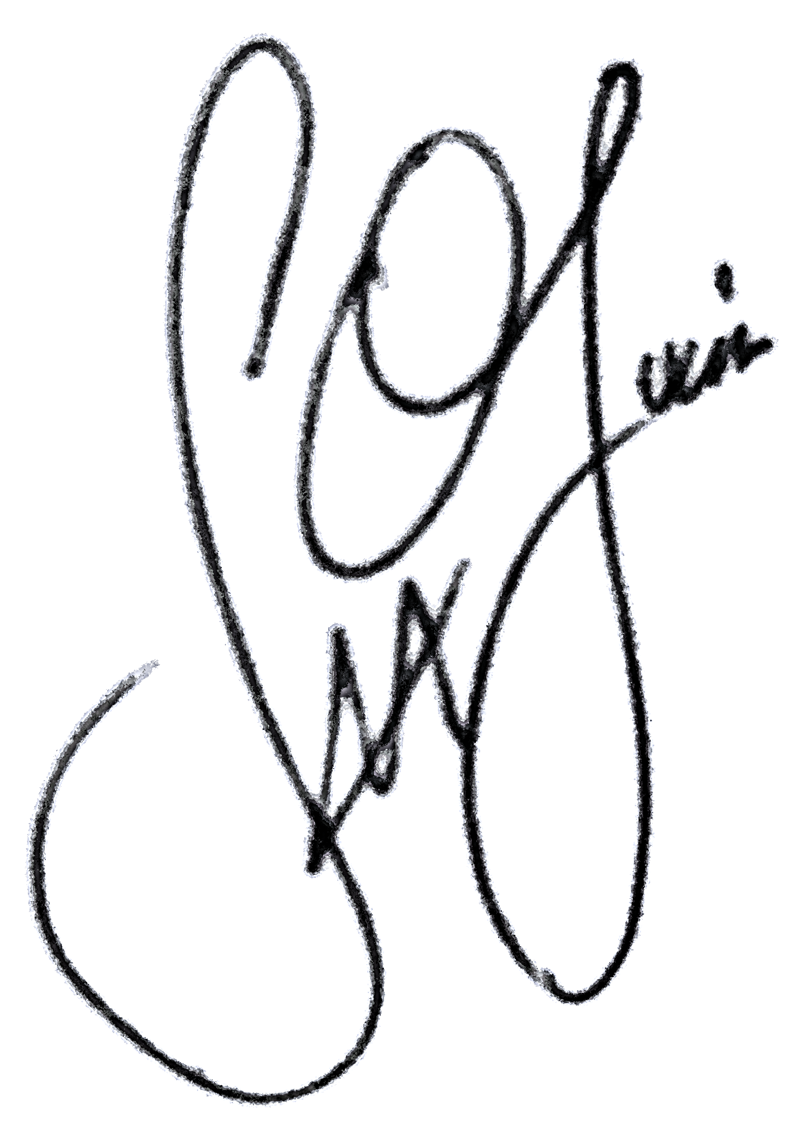

Signed:

Title: CEO
Date: 2/24/20
CLIENT:
PAGNY | HRF
55 W 125th St, Suite 1001
New York, NY 10027

Name:

Signed: __________________________

Title:

Date: ___________________________

(Schedules attached hereto)

